Beomjin Han

Dr. Mitchell

CSC 148

Homework 3b

1. 1. SIS size = 5 minutes  
   2. n_sis = 43.2 sis intervals  
   3. x^ = 2.315 arrivals / interval

|  |  |  |  |
| --- | --- | --- | --- |
| xi | Oi | Ei | (Oi-Ei)2/Ei |
| 0 | 3 | 4.247 | 0.366 |
| 1 | 7 (10) | 9.832 (14.079) | 0.816 (1.182) |
| 2 | 16 | 11.38 | 1.875 |
| 3 | 8 | 8.782 | 0.07 |
| 4 | 8 | 5.082 | 1.685 |
| 5 | 1 (9) | 2.353 (7.435) | 0.778 (0.329) |
| SUM | 43 | 41.676 | 5.59 |

1. Python program output:  
   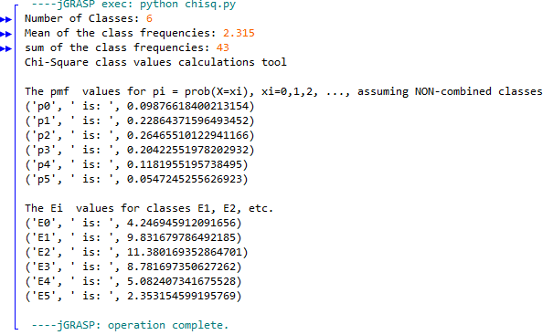
2. a)  
   1.  = ∑ (Oi-Ei)2/Ei = 5.59 is the test statistic value  
   2. v = k – s – 1 = 6 – 1 – 1 = 4 degrees of freedom  
   3. Xcritical on row 4, column 0.20 is 5.989

b)

Our calculated test statistic of d, which is , is 5.59.

 0.20, 4 which is shown in the table, is 5.989.

This means that our test statistic satisfies the null hypothesis and conforms to the distribution at the significance level of 0.20.